***TASK 1***

***TASK 2***

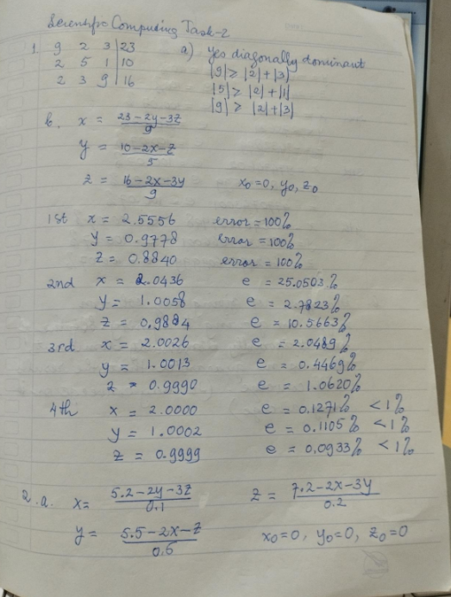

***TASK 3***

***ANSWER ON NEXT FEW PAGES***

***TASK 5***

***TASK 6***

